FULL PAPER TEMPLATE FOR CAADRIA 2022
A Microsoft Word document with guidelines and formatting styles
FIRSTNAME LASTNAME1 aND FIRSTNAME LASTNAME2
1,2Affiliation.
1emailaddress1@email.com 2emailaddress2@email.com
- DO NOT ENTER NAMES, AFFILIATIONS OR EMAIL ADDRESSES FOR PEER REVIEW STAGE -

Abstract. This template provides the formatting guidelines for full papers submitted to the 27th International Conference of the Association for Computer-Aided Architectural Design Research in Asia (CAADRIA). Please leave the word ‘abstract’ and its formatting. The text starts after inserting a tab. Provide an unstructured abstract of between 160 - 200 words, which contains the problem statement, article aim, original contribution, research question, methodology, and main conclusion. The abstract should not contain any references. Insert your paper title in the fields above, the use of the sub-title format is optional, please delete the field if it is not used.
Keywords. Five to Eight Keywords; Identify the Main Topic; Two to Four Words Each; Specific Instead of General; SDGs.
- Introduction
Authors of accepted abstracts are invited to submit blinded Full Papers for the second stage of the CAADRIA double-blind peer-review process. Inclusion of full papers in the conference presentations and proceedings publications will be subject to review acceptance, to compliance with submission deadlines and formatting guidelines, and to payment of the conference registration fee. This document contains the required guidelines and styles for formatting a full paper for CAADRIA 2022 conference publication. Please read and follow these guidelines carefully. Papers that do not exactly match the required formatting will be excluded from the reviewing process and proceedings publications.
- Paper Length

– LEAVE THIS WHITE BOX ON PAGE 01 !! – paper and conference information will be added here.
There is no maximum word count for full papers, but a limit of 10 pages when entering the text and images into this template. The paper content should be formatted EXACTLY similar to this example paper, using the formatting styles contained in the document. Adjustment of any of the formatting settings, including changing the page margins, font size, letter or line or paragraph spacing is not allowed.
The 10-page limit applies to all content combined, including main text, images, captions and bibliography. The number of images, their size and location within the text will affect the number of words that the paper can contain, and it is recommended to edit your paper in a comprehensive manner to achieve an efficient and well-ordered arrangement of content on your pages. The finalisation of your paper will require several rounds of editing content and visually inspecting the output. The total page count can be less than 10 pages but must be an even number (6 or 8 pages). For submission to the peer review process, you are required to create a PDF printed version of your paper from MS Word using this template.
- Body Text and Headings Styles
This is an example of the first paragraph of body text after a heading. These paragraphs do not have an indentation of the first line. Use the style ‘CAADRIA text first’ for the first paragraph after any type of heading.
All other paragraphs should be formatted using the ‘CAADRIA text’ style. These paragraphs have a 0.5 cm indentation of the first line. Please do NOT adjust any of the styles, fonts, line spacing etc., only the CAADRIA styles should be used to format your document.
For the heading at the start of this section, use the ‘CAADRIA heading 1’ style. All headings and sub-headings should automatically be numbered, except for the ‘Acknowledgements’ and ‘References’ heading.
- LEVEL 2 HEADING
Above is an example of the ‘CAADRIA heading 2’ sub-level heading. Their use is optional, use these when necessary to give the paper a clear content structure within the basic ‘IMRaD’ structure (Introduction, Methodology, Results and Discussion).
- Level 3 Heading
Above is an example of the ‘CAADRIA heading 3’ sub-level heading. Use this heading only if necessary, in the instance of very long level 2 sub-sections where the content needs to be structured.
- The Use of Images and Diagrams
Images, diagrams and graphs should be prepared as high-quality pixel based graphics and inserted in the full paper document. All figures and tables must be referenced within the body of the paper (e.g., “Figure 1 describes ….” or “results are listed in Table 1”). Images, tables and graphs should be inserted directly after or close to their description in the text. All figures should be captioned, following the example shown in Figure 1.
Use .jpg for photos and renderings (300 dpi, quality: High) or .png for graphs, line drawings, etc. (600 dpi). With the CAADRIA page format, the standard width of figures is 120 mm, which translates to a minimum image width of 1500 or 3000 pixels for 300 and 600 dpi respectively. The image width can be less than the full width of the text, and should use a centered horizontal alignment. After inserting an image, click the image and choose 'Layout Options / Top and Bottom' and 'See more …' and uncheck 'Allow overlap'.
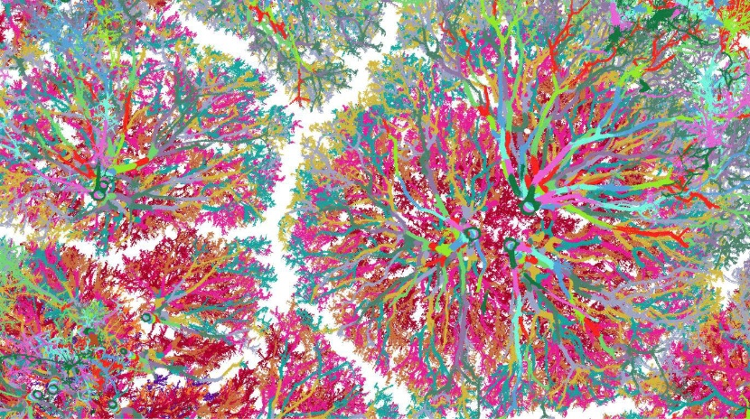
Figures should be well-readable and augment the text with additional information. If that is not the case (for instance: Grasshopper screenshots), editors may remove them during layout without further notice. If text is included in your graphs or diagrams, please make sure the text is clearly legible, compared to a minimum font size of 7 points when printed.
Figure 1. An image with a caption
Authors are expected to ensure that third-party materials that are copyright(s) are allowed to be republished, in which case the necessary credits should be included. This applies predominantly to photos showing work that does not belong to the author(s); if unsure these figures should be omitted.
- The Use of In-Text References and Citations
References to literature should be included using in-text references (not footnotes or endnotes), following APA style guidelines. The following examples refer to a work by a single author (Smith, 2014), two authors, (Smith and Jones, 2014), three or more authors (Smith et al., 2014). When you quote directly from a source or paraphrase a specific passage, the in-text citation must include a page number to specify where ‘the relevant passage is located’ (Jones et al., 2016, p. 155). Please use single quotation marks, except where ‘a quotation is “within” a quotation’. Long quotations should be indented without quotation marks.
All in-text references and citations should be included in the list of references. Only references that are mentioned in the text should be included in the list. For guidelines for the references section, refer to the last section of this document.
- Other Style Guidelines
This section contains some examples of other common layout elements, and describes some general formatting requirements:
- Please use a consistent style of English (British) spelling throughout your manuscript.
- Headings should use ‘Title Case’ capitalisation, e.g. “The Title of the Next Section”.
- Tables and formulas should be created in MS Word and not be inserted as images.
- For a bullet point list, use the style ‘CAADRIA list bullet’.
- For the last point in a bullet point list, use the style ‘CAADRIA list bullet last’.
- Originality and Publication Ethics
Papers submitted to CAADRIA should contain original, previously unpublished work and not be submitted to other conferences or journals. The text will be automatically scanned by our plagiarism detection software and may be rejected if there is an unusual similarity with other academic publications. Self-plagiarism is also prohibited.
Please take special care to avoid ambiguity when referring to other people’s work, text can only be a literal (copy-paste) duplicate of another source when it is placed in quotation marks and referenced with the correct author, year and page number. When previous research findings by other scholars are used without quotation marks, the text should be paraphrased in your own words and referenced.

Acknowledgements
The Acknowledgements is an optional section that can be used to thank those who helped with the research or made other important contributions. The named authors for the paper should include all and only people who have contributed to the writing of the article, following the Vancouver Convention on authorship. Corresponding authors should obtain approval of the final publication of all listed co-authors.

References
For the 'references' heading, use the ‘CAADRIA acknowledgements’ style. For the references themselves, use the 'CAADRIA references' style, and ‘CAADRIA emphasis’ for italic text inside each reference. The list of references of the paper should be formatted according to the APA Reference Style. All and only references that are mentioned in the text should be included in the list. Include DOIs if available. For the complete guidelines on reference formatting, please refer to the APA website. Some of the most common examples of literature references are given below.

A Journal Article:
Grady, J. S., Her, M., Moreno, G., Perez, C., & Yelinek, J. (2019). Emotions in storybooks: A comparison of storybooks that represent ethnic and racial groups in the United States. Psychology of Popular Media Culture, 8(3), 207–217. https://doi.org/10.1037/ppm0000185.

A Conference Paper:
Karoji, G., Hotta, K., Hotta, A., & Ikeda, Y. (2019). Pedestrian dynamic behaviour modeling. In 24th International Conference on Computer-Aided Architectural Design Research in Asia: Intelligent and Informed, CAADRIA 2019 (pp. 281-290). The Association for Computer-Aided Architectural Design Research in Asia (CAADRIA).

An Authored Book:
Sapolsky, R. M. (2017). Behave: The biology of humans at our best and worst. Penguin Books.

A Chapter in an Edited Book:
Dillard, J. P. (2020). Currents in the study of persuasion. In M. B. Oliver, A. A. Raney, & J. Bryant (Eds.), Media effects: Advances in theory and research (4th ed., pp. 115–129). Routledge.

An Online Resource URL:
Fagan, J. (2019, March 25). Nursing clinical brain. OER Commons. Retrieved January 7, 2020, from https://www.oercommons.org/authoring/53029-nursing-clinical-brain/view.

This is an example of what the reference list should look like:
Grady, J. S., Her, M., Moreno, G., Perez, C., & Yelinek, J. (2019). Emotions in storybooks: A comparison of storybooks that represent ethnic and racial groups in the United States. Psychology of Popular Media Culture, 8(3), 207–217. https://doi.org/10.1037/ppm0000185.
Karoji, G., Hotta, K., Hotta, A., & Ikeda, Y. (2019). Pedestrian dynamic behaviour modeling. In 24th International Conference on Computer-Aided Architectural Design Research in Asia: Intelligent and Informed, CAADRIA 2019 (pp. 281-290). The Association for Computer-Aided Architectural Design Research in Asia (CAADRIA).
Sapolsky, R. M. (2017). Behave: The biology of humans at our best and worst. Penguin Books.
Dillard, J. P. (2020). Currents in the study of persuasion. In M. B. Oliver, A. A. Raney, & J. Bryant (Eds.), Media effects: Advances in theory and research (4th ed., pp. 115–129). Routledge.
Fagan, J. (2019, March 25). Nursing clinical brain. OER Commons. Retrieved January 7, 2020, from https://www.oercommons.org/authoring/53029-nursing-clinical-brain/view.

(Apply the 'CAADRIA reference' style to all references, then use the 'CAADRIA emphasis' style to add italics. There should be no gaps in between the references.)

